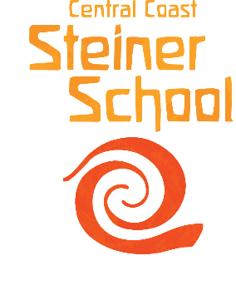

The Central Coast Steiner School caters to 285 students from Early Kindergarten- Year 10. We are located in a natural bushland setting in Fountaindale, on the beautiful Central Coast. We are seeking a Deputy Principal to join our contemporary, vibrant and caring learning environment.

The position is available as from Term 3 2022, however a Term 4, 2022 or Term 1 2023 start is also possible for the right applicant. The Deputy Principal role includes a 0.5 teaching role (primary and/or secondary).

Deputy Principal Selection Criteria:

- Understanding of and commitment to the philosophy and practices of Steiner education

- Experience in school leadership

- Ability to step up to the challenges of leadership, to act ethically and with personal integrity

- Dedication to the growth of a flourishing school community

- Demonstrated ability to articulate and enact expected standards, ethos and ideals so that a healthy school culture is sustained

- Demonstrated excellence in teaching and enthusiasm for the profession

- An ability to work cooperatively and consultatively with colleagues to bring out their strengths and mentor their professional growth, outstanding interpersonal skills

- Demonstrated calm, level-headed approach to challenges, ability to creatively problem-solve

- Commitment to developing positive relationships and working restoratively with students

- Well-versed in contemporary understandings of student wellbeing

- Well-versed in contemporary understandings of education, with a willingness to innovate, adapt and renew

- High standards of verbal and written communication, administrative and organisational skills

The successful candidate must also provide a Working with Children Clearance prior to commencing.

Approval to teach (NESA or equivalent) is required. Applicants are to provide a cover letter responding to each of the selection criteria, curriculum vitae, and contact details for three referees who have worked in a supervisory capacity to: principal@ccrss.nsw.edu.au

